Note: The MBR begins with a set of metrics on Page Zero on the state of the business, tracks key goals on Page 1, mentions the Hits/Misses/Learnings over the past month, and then provides July updates for each of the team’s three programs. It received positive feedback from L8 leaders on document writing and quality.
Doc Ninja Thoughts:
- What did the doc do well?
  - The author states a clear purpose for the initiative and supports it with the right level of data. The doc has a clear call to action linked to the goal and gets straight to the point in each section.
  - The doc is well-structured and flows from top-level details to more granular details.
- Where could the doc develop further?
  - The author can write more concisely by cutting unnecessary language. Consider this 46-word sentence: “The Contra-CoGS team proposed an alternate solution that would eliminate this issue during agreement creation by warning Vendor Managers attempting to set up short duration Straight Pay agreements and asking them to expand either the filters or the date range to prevent the agreement becoming unbillable.” We can break this up to say: “The Contra-COGs team proposed an alternative that will eliminate this issue during agreement creation. The solution will first warn Vendor Managers attempting to set up short duration Straight Pay agreements. It will then ask them to expand either the filters or the date range to prevent the agreement from becoming unbillable.”
  - The author wrote the MBR for a specific audience with subject matter expertise, but the document has undefined acronyms, jargon, and references to projects and roadmap stages that are difficult for non-SMEs to understand.
  - The narrative only references the Appendix once, so there are opportunities to more directly tie the content to the Appendix or streamline the Appendix.

TABLE 1: AGREEMENTS CREATED BY TYPE AND REGION
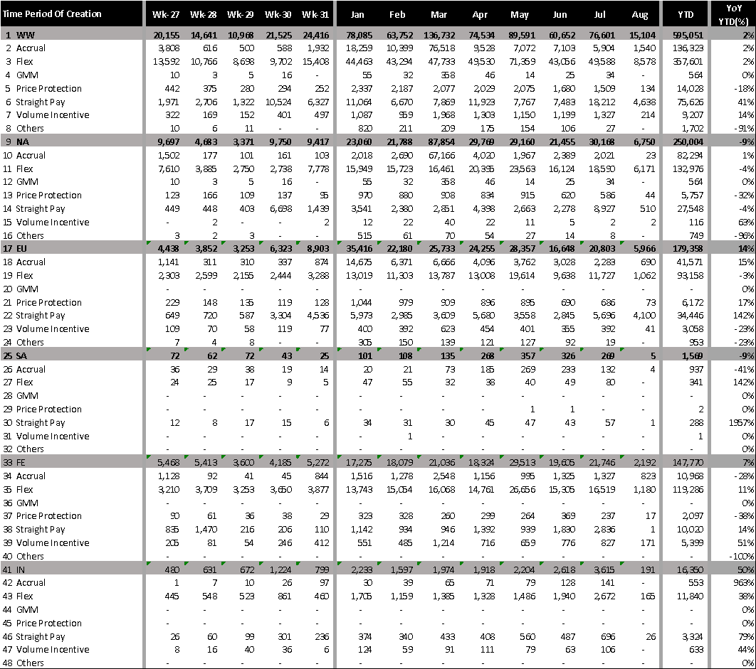

TABLE 2: DEFECTS
2.1 DELAYED CONTRA-COGS FUNDING
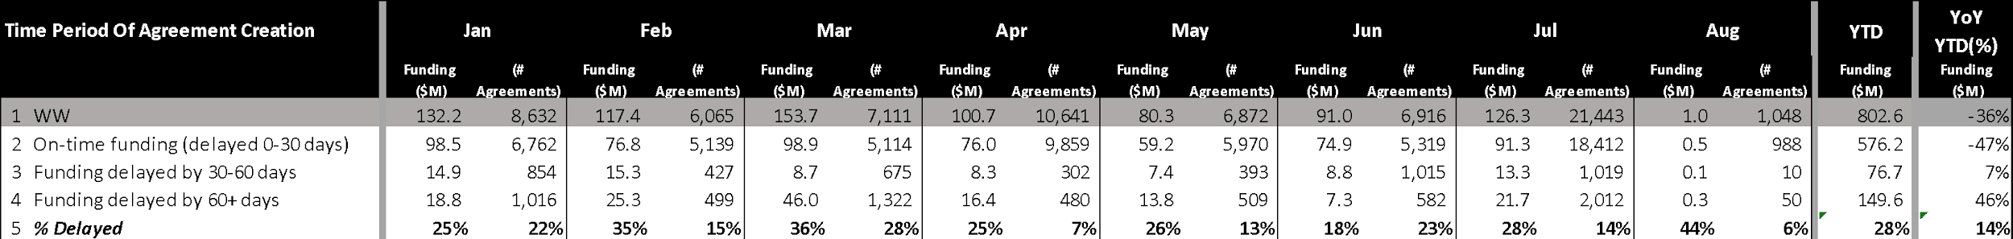
2.2 STRAIGHT PAY FUNDING
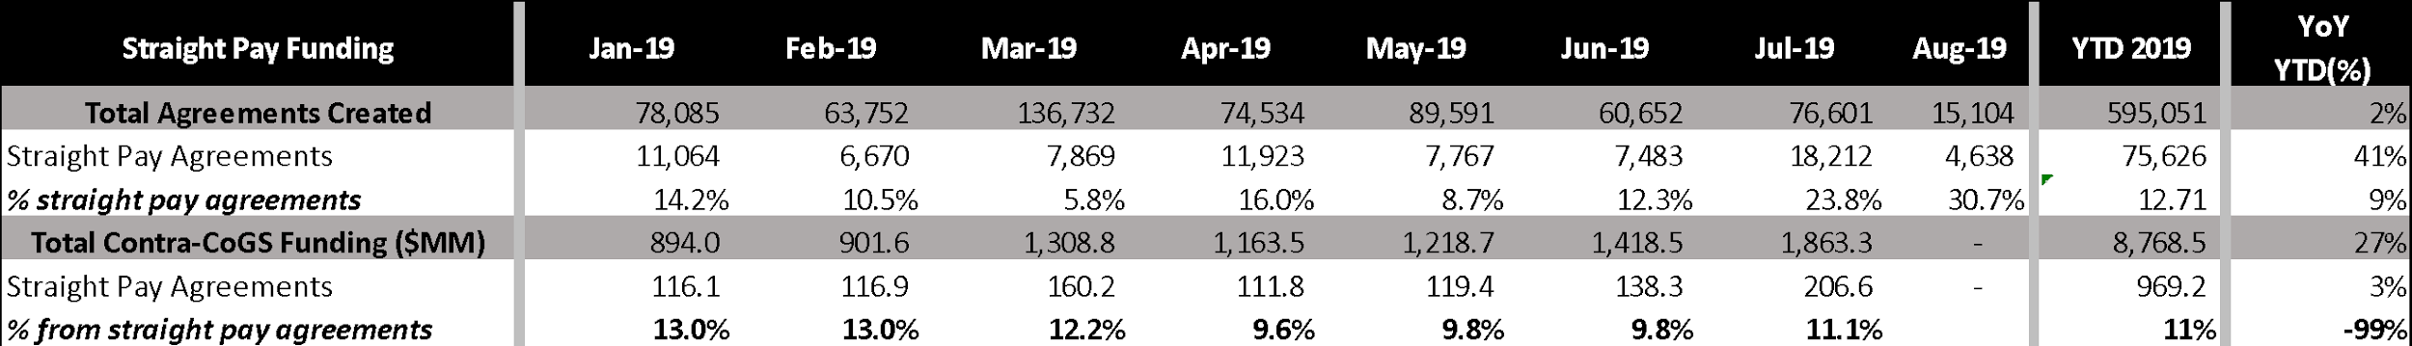
The Contra-CoGS Technology (CCT) team owns services that enable the creation, amendment, and financial execution of Contra-CoGS vendor funding agreements with robust controls to ensure financial accuracy. We enable Amazon to collect funds from vendors for agreements related to Amazon’s purchase, customer sales and/or marketing of their inventory, which in turn drives Amazon’s profitability and Free Cash Flow (FCF). We consider high praise from our customers to be “The Contra-CoGS tool contains several powerful features to capture vendor funding, but it remains trivially easy to use. Through actionable recommendations and custom reporting, it seeks to provide me visibility into my vendor’s funding and helps me achieve my target margins.”
In 2019, our focus is to reduce leakages and stuck vendor billings, simplify agreement offerings, and improve accounting accuracy via transactional booking. The purpose of this document is to provide an update on our July 2019 activities, discuss hotly debated topics and provide visibility into our upcoming roadmap.

July Summary
In July, Contra-CoGS saw creation of 76.6K agreements (+21% MoM), with the increase driven by 10.7K Prime Day related agreements that were created during the month. YTD 595.0K agreements (+2% YoY) have been created, of which 42% of agreements were created in NA, 30% in EU, 25% in FE and the remaining 3% in IN. The most frequently used agreement types were Flex (60%), Accruals (23%), and Straight Pay (13%), which together accounted for 96% of all agreements created. In terms of vendor funding, July saw accruals of $1.76B (+30.9% MoM), bringing YTD total accruals to $8.54B (+22.3% YoY). NA, EU, FE and IN accounted for 64%, 26%, 8% and 1% of the accruals respectively. Post-billing, vendors raised 2,356 disputes (-22.8% MoM) to Amazon amounting to $43.4MM (-48.8% MoM), of which $7.9MM (18.2% of total disputed amount) was paid upon resolution. The top reasons for successful disputes were duplicate agreements, agreements incorrect billing address and incorrectly setup agreements.
YTD, we have spent $817K in IMR costs to operate Contra-CoGS, which is 2% behind plan, down from 6% behind plan in June. July continued to reflect the benefits of our earlier moves from on demand to reserved instances for EC2 hardware. We have 39 BIS (SDE:27, DBE:1, RS:1, PM:3, TPM:2, SDM:3; SE:2) against 52 SPFT-funded HC, with 3 open reqs and 3 pending starts. We also have 4 SDEs funded by external teams of which we have 3 BIS and 1 pending start. In July, Contra-CoGS HC increased by 15 in order to accelerate leakage reduction.
Table 3: 2019 Goals Status (see contributing initiatives in Appendix 7)
 | Goal | Status | Comments
1 | Reduce missed and manually processed vendor funding from $107MM in Q4 2018 to $10.7MM in Q4 2019, a 90% reduction | RED | As of 7/31, we are Green for manually processed funding (€7.9MM as of 7/31; down 86% YTD), but we are Red for missed vendor funding since we have recently decided to pivot our strategy from capturing leakages via recommendations to preventing leakages via default rate cards.
2 | Reduce the number of Contra-CoGS financial errors due to software issues from 11 to 4, a 64% reduction by 12/31/2019 | DNM | Contra-CoGS has had 5 financial errors to 5 YTD in 2019, with a total financial impact of $110MM.

Hits, Misses and Key Learnings
Hits:
- Deprecated legacy Damage Allowance agreement type to simplify Contra-CoGS offerings: On 7/22, we completed the deprecation of Damage Allowance agreements as a separate agreement type. Legacy Damage Allowance agreements have been disallowed via the Contra-CoGS UI since 2018, but Vendor Managers could still create these agreements via pre-existing templates in Vendor Central (YTD 2.0K+ such agreements were created in 2019). With this change, all damage allowance agreements will be correctly configured as Accrual Agreements with “Damage Allowance” activity type regardless of source. Since 7/22, no new Damage Allowance agreements have been set up.
- Enabled CloudAuth for 2 services as part of native AWS accessibility S-Team goal: On 7/23, we enabled CloudAuth for the first two Contra-CoGS services (ContraCogsContractLanguageService and ContraCogsAgreementEventWorkflowSIL), in scope for migration as part of our contribution towards the AWS accessibility S-Team goal. CloudAuth allows these services to be accessed from Native AWS. We will migrate 8 more services to CloudAuth by 9/30, to complete our team’s contribution towards the goal.
- Launched Contra-CoGS for new GL 353 (Wireless Accessories) in IN: On 7/31, Contra-CoGS enabled support for GL 353, which was carved out of GL 107 (Wireless) in IN. This launch will help IN business create agreements in this GL, generate INR 500MM/USD 7MM (7% of GL 353 GMS) FCF in 2019 automatically, and save 100 man-hours annually by eliminating the need for manually billing vendors operating in this GL.
- SPS Finance successfully onboarded the EU month-end reconciliation process: SPS Finance has taken ownership of two EU month-end activities from the Bling team – (1) manual investigation of discrepancies and (2) investigating delayed CSI cap to P&L movements. For the first activity, we used Data Warehouse queries to reduce the 84 man-hour process to 29 man-hours (0.7K man-hours saved annually). For the second activity, SPS Finance published the July-19 report which identified EUR 1.1MM of late retroactive CSI release and ensured that the P&L account was correct for month-end close.
- Aligned with AR on simplified design for handling of Straight Payment billings without matching transactions (feature #6 contributing to Limbo reduction goal): Straight Payments agreements that do not have matching CSI or DSI transactions have driven €13.7MM EU Limbo YTD. Typically, these agreements are structured for very short durations (e.g. one day) during which Amazon has no transactions that match the filters set in the agreement. The initial proposal by AR for this feature relied upon a solution to determine the tax information based on prior transactions in TTM, which would have resulted in a complex system with high IMR costs and only provided an approximation of taxes. The Contra-CoGS team proposed an alternate solution that would eliminate this issue during agreement creation by warning Vendor Managers attempting to set up short duration Straight Pay agreements and asking them to expand either the filters or the date range to prevent the agreement becoming unbillable. We have received alignment from AR on this alternate solution and are now proceeding with the design.
Misses
  - Missed daily SLAs for Contra-CoGS calculation results for 13 days in July due to upstream issues: Widespread data delays and job failures due to BDT’s Rolling Stone activity and a Cradle-related LSE caused us to miss our 18 hour SLA for publishing Contra-CoGS to CP 13 times in July. We have requested a CoE from BDT for these issues.
  - Launch of IN First Contra-CoGS based on “% of List Price with Tax” delayed: As an industry practice, vendors in IN agree to Contra-CoGS as a % of MRP (Maximum Retail Price a.k.a List Price with Tax) since MRP changes less frequently than cost price. This feature is expected to generate incremental FCF of INR 1,015MM (USD 14.5MM) and eliminate 1.3K+ man-hours in manual computation annually. However, we have missed the 6/30 launch date for this feature due to the additional effort required in backfilling transactions with MRP values. Our revised plan is to launch Phase 1 of this feature in time for Diwali by using MRP values from Big Data tables (ETA 9/15) and follow with Phase 2 where MRP value will be backfilled using contribution catalog service, the source tool of publishing ASIN attribute contributed based on Vendor Codes (ETA 11/14).
Learnings
  - Vendor Managers use Straight Pay instead of Flex agreements to run promotions: During Wk 29, we noticed that Straight Pay agreements had a 500% increase in accruals from average $15-20MM per week in prior weeks to $100.7MM in Wk 29 (see Table 2.1 on Pg 10). While we expected Contra-CoGS accruals to spike during Wk 29 due to Prime Day related promotions, we were surprised to see the growth come in the form of Straight Pay agreements versus Flex agreements, which are meant for promotions. Our subsequent conversations with Vendor Managers revealed that the key reason for this behavior is their inability to set upper and/or lower funding limits for Flex agreements. Specifically, while Vendors are interested in capping their maximum liability, Vendor Managers are interested in establishing a minimum funding amount. From our perspective, we believe that using Straight Pay agreements for running promotions is not desirable because it reduces auditability of agreements for our auditors, since the agreements do not contain the actual funding accrual logic. In addition, Vendor Managers frequently use Estimated Reconciliation on other agreement types such as Accruals and Flex agreements to manually implement upper and lower funding limits (in 2018, ERs worth 130MM were created due to these reasons). Based on this learning, we have now added a feature in our roadmap backlog to allow Vendor Managers to cap agreements to the desired amount. As part of the feature, we will develop the right set of controls that would allow Retail Finance to audit the specific caps used in each agreement.

Improving Customer Experience
In 2019, 4.0K distinct users WW have created at least one agreement in our tool. More broadly, the customers of our tool include internal Amazon users such Vendor Managers, Finance Partners and Auditors who create, approve, manage, and audit agreements as well as vendors who sign agreements, receive invoices, and make payments.
We have a 2019 goal to launch 5 features to simplify the Contra-Cogs UI that drive user productivity, reduced errors and ensure compliance. Based on findings from our customer survey and interviews with Vendor Managers this year, we have identified five potential improvements: (1) duplicate detection, (2) centralized billing contacts, (3) agreement preview, (4) improved payment terms and (5) implement bulk sign and bulk disposal functionality. We have launched bulk sign and bulk disposal on 6/15 and put other projects on our roadmap.

Recent roadmap updates
- Duplicate Agreement Detection: Vendors are highly sensitive to being billed twice for the same transaction, which can occur if a VM creates a duplicate agreement with similar terms. In 2018, duplicate agreements drove 39.6% of all vendor disputes ($619.9 MM). In Q2 2019, we developed a BRD for a new feature that would check agreement as it is being created and inform Vendor Managers of potential duplicate agreements. We expect this feature to reduce vendor disputes on duplicate agreements by 50% ($310.9MM) within 6 months of the launch. Currently, the project is in implementation phase and we are green for delivering phase 1 by 9/30.
- Centralizing Billing Contacts: Due to the shortcomings of the existing billing contacts management workflow, Amazon is sometimes not able to bill vendors successfully. In 2018, disputes related to billing contact information accounted for $31.3MM leading to estimated $20MM in fines and processing costs for correcting invoices. In Q2, we developed a BRD for migrating billing contacts from Contra-CoGS to an authoritative source in Vendor Central and informing the vendor about the billing contact details when sending them the finalized contract, to allow them to verify the contact information. Along with the impact to vendor disputes and vendor experience, this project will also clean up long standing billing contact management tech debt for our team. In July, we worked with VENAM team in Vendor Central and completed high level design and scoping for this project. Based on our scoping, this project needs 33 SDE weeks of effort, of which 22 weeks are needed in the VENAM team. We are currently working with VENAM team to fund this work as an away team and will gain a final alignment by 8/14, which would allow us to launch this in Jan 2020.
- Agreement Preview: In 2018, disputes related to incorrect agreement setup accounted for $220.8MM. VM feedback revealed that these issues resulted from Vendor Managers not being able to understand the billing amounts that an agreement would generate, before sending the agreement to the vendor. To eliminate such disputes, we developed a BRD for an Agreement Preview feature that would allow Vendor Managers to inspect the potential billing amount of an agreement before sending the agreement to the vendor for signing. We are currently working to complete the project design by 8/30 and expect to launch the feature in early Jan 2020 after holiday restrictions are over.
- Payment Terms: 10% of Contra-CoGS agreements typically contain a payment term. The payment term is an optional, free text field that provides information about the credit terms we have given to the vendor (e.g. "2 10 NET 30" means 2% discount if paid by vendor within 10 days, otherwise the net due is in 30 days). Our deep dive has revealed that over 95% of agreements that have a payment term do not map to the correct AR terms. This causes a poor vendor experience as their requested payment terms are not respected. We plan a replacement of the free text field with the dropdown menu of OFA valid terms. We are currently finalizing requirements, design, and scoping (ETA 8/30).
- Extending Transaction Grabber to Special Merchant of IN: Currently, Contra-CoGS can send the Transaction Grabber report to internal Amazon employees only, which doesn’t scale for IN business that has Special Merchants that need the same report. Without a solution, IN FinOps and RX tech typically see average 300 tickets monthly IN Vendor Managers requesting the report for their agreements. We are now extending the Transaction Grabber report to IN Special Merchants to eliminate these tickets and make the process self-service for IN Vendor Managers. In addition, users will now be able to see the Transaction Grabber reports on the UI as well (instead of receiving via email). We are currently green to launch this solution in IN and remaining geographies WW by 9/15.

Eliminating Agreement Defects
  - Leakages
Contra-Cogs Leakage refers to missed collection of vendor funding that is rightfully owed to Amazon. Leakages result from two root causes (1) missing or incorrectly configured agreements, and (2) defects in calculating vendor funding. Currently, we engage four audit teams that identify wrongfully built agreements where we have under-billed vendors and issue associated claims to those vendors. In 2019, we expect audit recoveries to yield upwards of $262MM in missed vendor funding with the bulk of the recoveries delayed until 2021 due to 18-24 month time lag of audits. In addition to bearing the cost of delayed cash flows (est. $40MM per year), we also pay auditors up to 14% of recovered amounts in commissions (est. $21MM per year). Further, since external auditors (who recover ~80% of all leakages) do not actually fix the wrongfully built agreements, Amazon pays external auditors for finding the same gaps again during next year’s audits. We consider leakages as a defect in our system as it costs Amazon in delayed cash flows and audit fees, understates profitability in the Contribution Profit (CP) system used by several automated decision making systems, and negatively affects the vendor experience by billing them for historical missed agreements.

In 2019, we are reducing leakage by capturing shipments that are reported late in our system. In June, we expanded the processing window for Customer Shipments Items (CSI) from 1 day to 5 days and this initiative has recovered $3MM YTD (expected $15MM annually). We will now pivot our leakage strategy to eliminate leakages from wrongfully set up agreements, which constitute 75% of all leakages. Our deep dives have revealed that root cause of wrongfully set up agreements is the need to create multiple, granular agreements to collect vendor funding. Going forward, we will vastly simplify Contra-CoGS agreement creation through smart defaults and automation and eliminate the manual work for Vendor Managers. We will partner with Retail teams to develop a standard rate card for each GL (e.g. 8% base accrual, 5% freight allowance, and 2% damage allowance) that would apply uniformly to all vendors operating in that GL. For vendor that have negotiated terms and need to differ from the standard rate card, GLs will be able to apply alternate rate cards. We are currently socializing this proposal with Retail teams WW and will present a PRFAQ on this topic by 10/31/2019.

  - Limbo
Limbo is defined as the amount of vendor funding that we are unable to bill to the vendor. Limbo typically occurs when we are unable to locate tax information for the underlying transaction of an amount or when computed billing amounts do not match the expected amount (due to exchange rate discrepancy, missing shipments, and rounding errors).
In 2019, we have a goal to achieve 90% reduction in limbo in EU through launch of six features. As of 7/31, we are Green to the goal with EU limbo at €7.9MM (-86% YTD). We have launched five of the six features – 1) direct integration from Contra-CoGS to Tax Engine (Mar 2019), 2) deriving tax for consignment inventory recorded in a country where vendor is not VAT registered (Mar 2019), 3) tax billing solution for vendors with multiple VAT IDs (Apr 2019), 4) tax billings to derive taxation for retail inventory using ‘ship-from’ location from Advance Shipment Notice (ASN) as a fallback to missing vendor invoice (Jun 2019) and 5) deriving tax for inventory procured from RoW vendors (Jun 2019). We are on track to launch feature #6 (tax billings to derive taxation for Lumpsum funding with no matching sales/inventory by using correct VAT treatment based on agreement period with sales/inventory VAT info and provide reporting for reconciliation) by 11/29.

Driving FCF through GMM Agreements
GMM is a negotiated agreement whereby a vendor guarantees a minimum profitability margin rate to Amazon. When the actual margin is below the negotiated minimum margin rate, the vendor is invoiced a true-up to cover the difference. With this margin insurance, GMM allows Amazon to preserve and expand price-competitive Retail selection profitably. While GMMs have several advantages, a lack of an automated GMM solution has historically required Retail to execute manual GMM agreements with known leakages. To plug these leakages and allow easier GMM creation and management, in Nov 2018, we introduced GMM as a new agreement type in the Contra-CoGS tool. Our longer-term vision is to have a default GMM contract for every Retail ASIN, to protect our margins from unexpected events.
  - GMM adoption and GMM Promotion Issue Update
As of 7/31, users have created 881 GMM agreements (+19 MoM) covering 12.6K ASINs (+900 MoM) with $36.5MM annualized accrual rate (+$2.3MM MoM) based on signed agreements.
In May, we learned that GMM had a flawed assumption during launch in Nov 2018 that Product Revenue (PRev) does not include any promotion related discount. In 1.2% of promotion related shipments, the discount is baked into PRev which leads us to understate margins and thus, overbill our vendors. Because our fixed GMM margin calculation will now use Sales Discount as an input, there are also cases where margins were overstated, and our vendors have under billed (affecting 12% of agreements in June). Apart from wrongful billing, this issue impacts CP and other systems that use GMM data. Our final impact measurement is $1.2M of over-billing on 58 invoices, during January through April.
Working through the issue with our business partners, we approved a plan to fix with Hardlines and Consumables leadership in July. The fix has been validated in our beta environment and we are proceeding through the necessary steps to deploy to production (remaining work is mostly related to backfills) and will deploy the fix in August. Billing for GMM has been paused since May, once we deploy the fix, GMM invoices for $8MM will be generated May through July. Hardlines and Consumables will use a Garter based process to manually refund vendors for the 58 invoices over-billed.
Once we fix this issue, our next focus will be to improve GMM adoption. We will send a broad email in September to all manual GMM users addressing advantages of automated GMMs vs manual GMMs and also announce the availability announcement of Bulk ASIN-Level GMMs (described in 5.2, below). In addition, by 9/30 we will develop a dedicated GMM training to allow Vendor Managers that don’t use manual or automated GMMs today to learn about advantages of using GMM agreements to protect their margins. We will keep this training updated as newer features such as ASIN-level GMMs launch.
  - Bulk ASIN-Level GMMs and long-term vision
Our most requested feature from retail teams is Bulk ASIN-Level GMMs, which require each ASIN to meet a margin target as opposed to our current GMMs which meet overall margin across all ASINs covered in the agreement. GMMs are most effective at eliminating CRaP and reducing Out of Stock (OOS) when invoice charges are calculated at the ASIN level, which prevents mix effects from diluting the impact of GMM. This approach maximizes FCF for Amazon as vendors cannot use a high margin ASIN to offset another ASIN that below its minimum margin. In May, we accelerated our work on bulk ASIN-level GMM and we are currently on track to launch it by 8/31. The code complete was reached on 7/31 and we are now validating in beta by comparing the amounts booked by single ASIN agreements (which have effectively the same margin calculation) to Bulk ASIN GMMs on the same ASINs. Once our internal validation is completed, we will allow our business partners to perform UAT before we launch it in production.
In parallel, we are working on a PRFAQ articulating our long-term vision of ‘GMM for every vendor’. We believe that formal, signed, and automatically-calculated GMMs should be a core element of retail’s vendor negotiation strategy as it sets a profitability floor for our negotiations. Our PR/FAQ will include a vendor manager playbook to drive adoption and configurable features to customize GMMs according to business needs. Our final internal review is scheduled for 9/2, after which we will review with SPFT and WW retail leadership.

Key Project Updates
  - Ensure Regulatory Compliance
We must ensure our business remains compliant with evolving geography-specific regulations, while our selling partners have all the data to meet their legal obligations.
Enhance Contra-CoGS system to support multiple tax rates for JP regulations impacting ~8K agreements totaling $33M/Q in billings [Phase 1 – Non Service, Launch Date: 9/30, Status: Green] – The 2019 Consumption Tax (C-tax) rate change in JP will increase the standard C-tax rate from 8% to 10% on 10/1. With this change, Amazon must collect and pay 10% C-tax for any applicable ASINs on and after 10/1 regardless of order date. In addition, the legislation introduces a reduced rate of 8% for food and non-alcoholic beverages. Without changes to the system, any agreement with a different then default rate on 10/1/19 (e.g. 8%) will need manual billing correction adjustment. As of 7/31, we have completed dev changes, currently in test phase and are on track to deliver by 9/30. To maintain consistent architecture across both non-service and service agreements, we plan a Phase 2 release for Q2 2020.
  - Ensure Financial Accuracy
Launch Transactional Booking Fast follow features and expand to the solution to US, CA and MX [Launch Date: 12/31 Status: Yellow] – In July, we worked on the final EU fast follow features - billing rounding error correction, cap rounding error correction and the launch of digital agreements on transactional booking platform. As of 07/31, we received UAT signoff for billing rounding error correction and are currently working on UAT for cap rounding error correction and support for digital. The billing rounding and cap rounding solutions are slated to be launched by 08/31 with the digital solution to be launched by 09/15. We have started work to expand transactional booking to CA, MX, and US with work on Flare configurations and stack setup for NA. We are Yellow for launching the MX intercompany transfer tax solution and are currently working with the Tax Engine Business and GIS teams on the integration required to support the NAFN tax use case.
  - Scaling with Technology
Evolve the Transaction Store to improve the accuracy of Contra-CoGS calculations, eliminating manual processing for ~$10M TTM [Launch Date: 10/31, Status: Green for revised date] – In July we completed the basic infrastructure for the transaction store and began backfill of data from previous years. We encountered performance issues during the backfill process, and we have pivoted to a new data load strategy to ensure the system performance required to extract and load 5 days of Customer Shipment Items each day. The launch date has moved from 9/30 to 10/31 due to this shift.

Updates to Previously Discussed Hotly Debated Topic(s)
  - Should we allow Contra-CoGS to be used as a billing solution? [June MBR]
As a follow up from June MBR, SPFT Finance partnered with Accounting and FinOps to determine how internal teams should obtain vendor funding when Contra-CoGS is not suitable to use because (1) the funding’s terms do not fit into an existing agreement type, (2) manual interventions are required due to Contra-CoGS not generating the appropriate accounting and financial entries, or (3) the original funding agreement is for a seller that also has a retail relationship with Amazon. The consensus is to use FinOps’ CREATURE tool because it supports granular accounting entries, the ability to deduct directly from vendor payments, and has a systematic approvals workflow to ensure proper oversight.

Hotly Debated Topics
8.1 Should we auto-renew unsigned agreements?
Currently, when a Contra-CoGS agreement is edited, its state turns to unsigned and it requires a fresh acceptance and signature from the Vendor and Retail Finance respectively. If the agreement is unsigned by the time the date for auto-renewal comes up, the agreement is not auto-renewed. This behavior often leads to leakages as Vendor Managers are unaware that an unsigned agreement will not auto-renew and they are not provided a notification informing them that their agreements have not auto-renewed. Such agreements that do not auto renew are today caught by our audit teams who generate claims to vendors to recover the funding owed to Amazon. To prevent such situations from occurring, we are considering changing our policy to allow our system to now auto-renew unsigned agreements. However, this policy may grow our overall disposals as some unsigned agreements will not gain approvals from Vendors and Retail Finance. Based on our analysis, Retail Finance approves ~90% of all agreements and so, we argue that allowing auto-renewal of unsigned agreements will create less damage than the damage from agreement leakages.
Longer term, we believe that we should introduce agreement versioning in our agreement model, so that in case the edited agreement is not accepted by Vendor or Retail Finance, the system will automatically fetch and renew the last accepted version of the agreement.

Appendix 1: Frequently Asked Questions (FAQs)
- What are your tenets?
Unless you know better ones …
  - Security & OE – Security and the Operational Excellence of our systems is our highest priority.
  - Accuracy – We guarantee 100% accuracy and completeness of Contra-CoGS data. We provide controls to identify and mitigate issues before impact is experienced.
  - Audit – Our services must provide data and tools to audit and fix any error in financial data in a timely manner.
  - Timely - We ensure financial transactions have been posted promptly, ideally on the calendar day of their occurrence.
  - Transparency – We build trust with our clients by providing clarity into financial data through consistent user experiences.
  - Governance – We implement systematic controls that ensure all Contra-CoGS transactions adhere to our tenets.
  - Business Growth - We provide a simple, intuitive solution for our customers to leverage our services. We provide tools, APIs and reports that are easy to understand while still providing features and power required by sophisticated and demanding customers.

- What products do you own and what businesses do you support today?
The CCT team has WW product ownership of the Contra-CoGS tool and associated APIs. Through the tool, we support the following businesses: WW Consumer (Retail), Digital content, Amazon Business, Subscribe and Save, Amazon Fresh, Prime Now, Amazon Go, Amazon Bookstores and Amazon Global Store.

- What executive escalations have you received in 2019 and what is the status of action items from those escalations?
  - CBR escalation about Apple’s funding not flowing to CP [Received 3/13]
We’ve already helped the Apple VM (burkard@) to set up Volume Incentive type agreements that closely approximate the per-unit funding during the quarter. The VM will then use offline calculations and correct the agreement’s booked amount via Estimated Reconciliation (ER). This action ensures a bulk of the Apple’s funding will flow to CP in time.
For the longer term, we carried an investigation into retrospective lump sum agreements, which is how Apple’s original agreements were set up. We have taken three action items to complete this investigation:
- Refine the delayed agreement list to exclude CP only shipments and shadow Contra-CoGS agreements to provide an accurate entitlement. (ETA: 5/30, Owner: seansu@, Status: Completed)
- Create an action plan that will eliminate delayed and CP only agreements. (ETA: 5/30, Owner: tulin@, Status: Completed. Starting June, we send a monthly flashes to users creating retrospective agreements and their L8 leaders.)
- Partner with accounting to drive clarity on the materiality of VFCC MJEs that circumvent the Contra-CoGS system. (ETA: 5/30, Owner: tulin@, Status: Not completed, deprioritized in favor of doubling down on delayed agreements.)

  - Hardlines ‘Insights and Innovation’ flash callout on wrongful Contra-CoGS agreement [Received 5/7]
The flash called out a mistakenly set up Contra-CoGS agreement which was discovered during an audit. Upon investigation, we discovered that this audit resulted from an automatically approved recommendation. As of 5/1, we’ve paused automatic approvals.

  - CBR escalation about a US Baby GMM agreement that pushed specific ASINs to CPLF negative [Received 5/8]
Our investigation revealed that the agreement in question was a manual GMM agreement, not an automated GMM agreement. Manual GMM agreements do not push their funding to Historic CP, which is a known risk. The specific callout in CBR was that the business knows the driver for spike in CPLF negative share and expects it to return to normal, once the VM enters the true amount in Contra-CoGS as a Straight Pay agreement.
While our team does not own any direct action items from the escalation, it’s interesting to note that the VM deliberately chose not to use online GMM, since the vendor required a quarterly true ups and a true up cap (both features not supported by our current GMM product; see Section 7.1 for details). We will use this learning to prioritize configurable GMM on our 2020 roadmap.

  - GST DN billing failures led to INR 240MM (USD 3.4MM) stuck in limbo for May-June 2019 [Received 5/9]
IN Special Merchants transitioned to GST DNs with transacting vendors in Apr’19 to utilize Input Tax Credits (ITCs) available to them against purchases from these vendors. Prior to this, they were issuing FDNs or GST Invoices. For GST DNs, CCT calls VPS for every transaction (DSI-CSI) to fetch tax information from AP invoice using a) Shipment ID b) Order ID c) Vendor Code d) ASIN e) Warehouse ID and f) Legal Entity ID. Tax information (Ship From and Tax Rate) is fetched only if there is a corresponding AP Invoice for this combination. These transactions are aggregated into sub-amounts based on a) Period b) Product Group c) Vendor VAT d) Amazon VAT e) Warehouse Code and f) Tax Rate. The sub-amounts successfully bill only if all the transactions within a sub-amount have tax information. 20% of total transactions were causing the billing failures. To solve this problem, we worked on two solutions a) R4C in the short-term and b) VPS logic change to increase hit-rate to 95% for fetching AP Invoices. The R4C solution was customized for IN and it is currently in UAT. ETA: 7/12. This will help sub-amounts without tax information bill with 0% tax rate (equivalent to FDN) instead of a complete billing failure. A permanent change in VPS logic will be deployed by 8/31.

- What keeps you up at night?
  - Limited transaction oversight: Our top priority is to ensure the accuracy of our financial statements; however, today we have limited support from SPS Finance to ensure the accuracy of our financials at the transactional level. SPS Finance has on-boarded the EU month-end reconciliation activities for July-19 , directly working with Accounting for sign-off, and improved throughput using Data Warehouse queries. SPS Finance is working on an incremental headcount ask with SPS and NA Physical Consumer Finance leadership to provide controllership and business partnering support for WW.
  - Lack of support for Digital GLs: While Contra-CoGS was originally built for Retail, we know that Digital businesses receive Contra-CoGS funding as well. Currently, our systems either lack integration with data sources containing digital transactions (e.g. for Prime Video) or have a discrepancy in the amount we bill vs. the amount that the agreement owner expects (e.g. for Kindle). More broadly, we do not know the list of Digital businesses and what portion of them need Contra-CoGS support. Our plan is to reach out as part of OP1 to these teams and obtain their requirements.

- What are your Business Architecture and Data Integration (BADI) initiatives?
BADI is an initiative to address tech debt across Amazon business and remove manual efforts across Finance and Accounting teams.
  - Launch Contra-CoGS Transactional Booking WW [Launch Date: 12/31, Status: Red] – The current process for recording (booking) Contra-CoGS to the Amazon financial statements relies on monthly batch processes through Oracle Financial Applications (OFA) and manual journal entries by Accounting. This is coupled with manual processes by Accounting to record Contra-CoGS capitalization and on-hand inventory adjustments to state properly the P&L and balance sheet. In 2018, we launched the Transactional Booking in EU project that removes the reliance on OFA as well as other manual processes. It enables the accurate booking of inventory movement in the EU and provides transactions daily to Accounting thereby avoiding end-of-month surprises. JCT priorities have delayed the WW launch, but rollout in all marketplaces will be phased through 2019 and 2020.
  - Eliminate Contra-CoGS EU VAT Limbo [Launch Date: 11/15, Status: Green] – In 2019, CCT has a goal to achieve 90% reduction in limbo in EU through launch of six features. As of 7/31, EU limbo stands at €7.6MM (-86% YTD). We have launched 5/6 features – 1) direct integration from Contra-CoGS to Tax Engine (Mar 2019), 2) deriving tax for consignment inventory recorded in a country where vendor is not VAT registered (Mar 2019), 3) tax billing solution for vendors with multiple VAT IDs (Apr 2019), 4) tax billings to derive taxation for retail inventory using ‘ship-from’ location from Advance Shipment Notice (ASN) as a fallback to missing vendor invoice (Jun 2019) and 5) deriving tax for inventory procured from RoW vendors (Jun 2019). We are on track to launch feature #6 (tax billings to derive taxation for Lumpsum funding with no matching sales/inventory by using correct VAT treatment based on agreement period with sales/inventory VAT info and provide reporting for reconciliation) by 11/29.
  - Improve the accuracy of Contra-CoGS calculations [Launch Date: 12/31/2019, Status: Green] – In June, CCT completed the world-wide launch of an expanded transaction processing window on customer shipment data (CSIs) from 1 day to 5 days. Since launch, $3MM of leakage has been prevented by this change. In July, we continued work on the new Contra-CoGS Transaction Store, which will improve our ability to query and modify data for improved accuracy.
  - Improve the Contra-CoGS UI and agreement creation safeguards [Launch Date: 12/01/2019, Status: Green] – We have identified five improvements (1) duplicate detection, (2) centralized billing contacts, (3) agreement preview, and (4) improved payment terms (5) Implement bulk sign and bulk disposal functionality. We launched bulk sign and bulk disposal on 6/15. The BRD for duplicate detection and centralized billing contacts are completed and fully approved on 6/30. We're currently working implementing phase 1 of duplicate detection by 9/15 and we’ve completed high level design of centralized billing contacts in July and are working with related teams to schedule necessary work.

Appendix 2: Action Items from previous MBRs
Action Items from June MBR:
- Insert Contra-CoGS WBR slides into SPS deck. (Carson/Arjun)
Status: In progress. We have finished automating slides for agreement volume, accruals, and retrospective agreements.
- Create a new report (or evaluate existing mechanisms) to monitor the % agreements that remain unsigned, so as to proactively identify software or process issues. (Nikhil)
Status: In progress. We’ll include this as a requirement in our next batch of WBR automation.
- Inform users who create DA agreements that we’re deprecating DA as a separate agreement type. (Nikhil)
Status: Completed. There were no concerns expressed as users in Vendor Central are automatically redirected to the correct way of creating DA agreements.
- Examine available solutions to bill vendors for non-CSI/DSI transactions and recommend if Contra-CoGS should expand its scope to support such use cases. (Carson)
Status: Completed. SPFT Finance, Accounting, and FinOps agreed to use CREATURE; which is a tool owned by FinTech.

Pending actions from prior MBRs:
- Expand scope of the GMM PRFAQ to include a summary of the GMM product today and our North Star vision. Review it with international teams and PGs other than Hardlines. (Kirk)
Status: In progress. We’re reviewing PRFAQ with international teams and remaining PGs. A final leadership review of the PRFAQ is set for 9/3.
- Create a work stream to strengthen our software testing practices and include an update in next MBR. (Jazz)
Status: In progress. The team is currently inspecting our MCM processes with a focus on updating and clarifying pre and post-deployment validation steps. In 2020, Contra-CoGS will dedicate 4 engineers to creating robust test environments, data sets, and improved controls to ensure accuracy of our systems.
- Share detailed plan for building transaction oversight for Contra-CoGS with Priya. (Carson)
Status: SPFT Finance has taken ownership of EU’s Source-2-Subledger Reconciliation as of July close and will meet with Priya and Aaron on 8/19 to review Finance’s resource prioritization on how to increase controllership support.

Appendix 3: Contra-CoGS Product Slides
The slides below are meant to put together a product view of the Contra-CoGS system. Currently, we have slides on the accruals by agreement type, GMM adoption, and true ups amounts for GMM. See Pg. 0 for slides on agreement creation WW and the two defects that we track today (retrospectively set agreements and straight pay agreements).
2.1 Accruals by Agreement Type ($MM, WW)
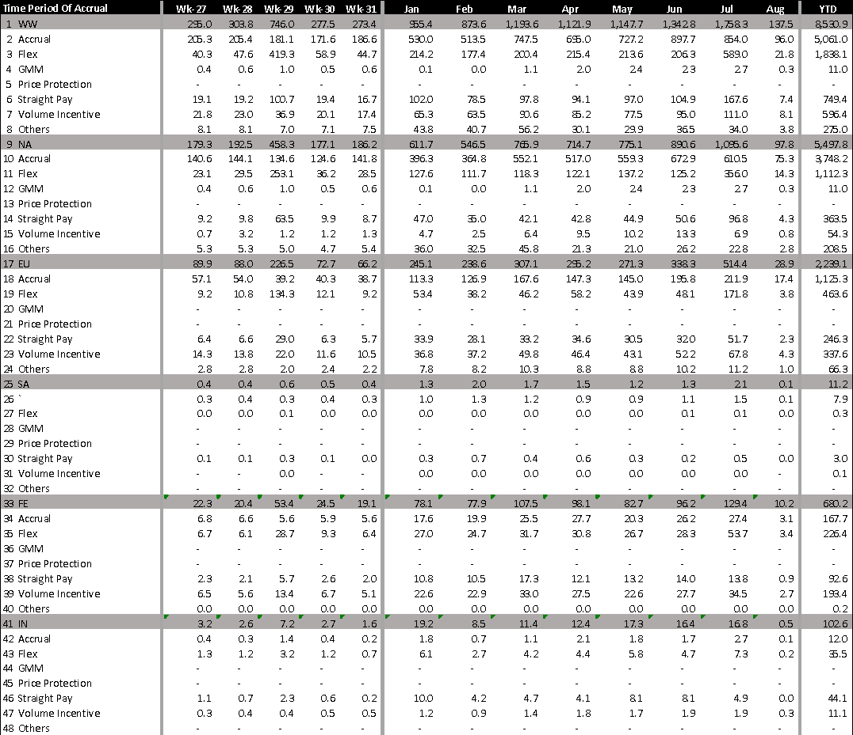

2.2 GMM Adoption vs. Entitlement (US Marketplace)
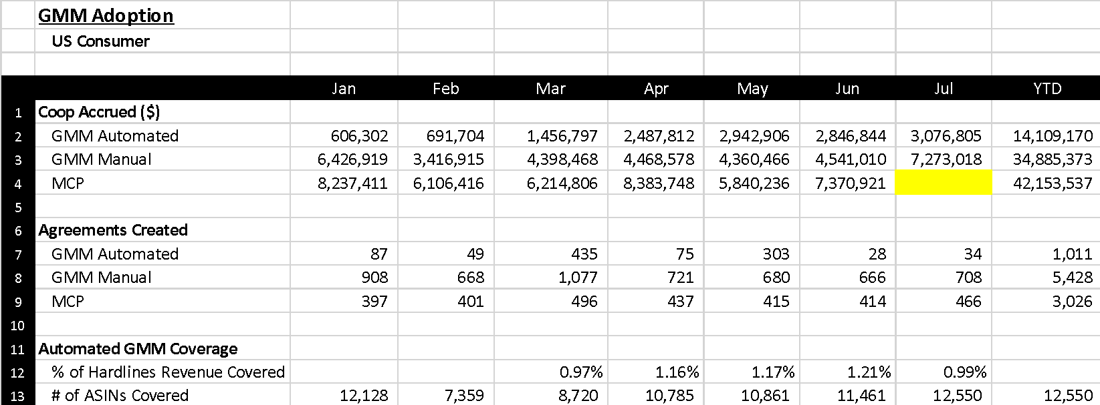

2.5 GMM Metrics (US Marketplace)
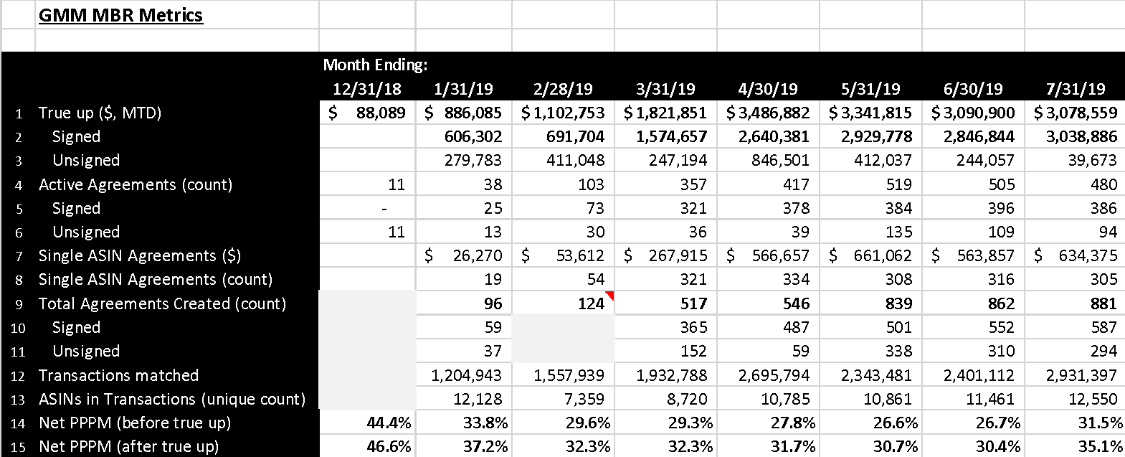

Appendix 4: Away Team Projects
Active:
- Launch Contra-CoGS automated booking and billing for Retail in UAE, KSA and EGY [Launch Date: UAE- 5/15 6/5 6/12 6/20, KSA – 07/30 11/14, EGY – 09/30 TBD, Status: Green] – UAE: The first phase of Contra-CoGS booking and billing launched on 6/25. For Phase 2, MENA tech is working on resolving issues encountered during Phase 1 UAT and PVT for the following agreement types a) Non-Service Accrual, Flex, VIR: MENA tech investigating solution around migration inventory DFD 8/9 and b) Non-Service Straight Pay: R4C solution needs to be enabled for UAE. Launch ETA: week of 8/18. KSA: Green for Auto booking/billing parity launch on 11/14 considering UAE implementation. With KSA custom TE requirements available, MENA tech is scoping a timeline for a fast-follow customized solution. There are 2 open topics that need to be closed to finalize scoping 1) Non-Service R4C setup and 2) Service – out of country address requirement. (ETA: TBD, Owner: mardi@)
- Launch Contra-CoGS UI improvements to streamline EU vendor management [Launch Date: 7/31 8/13, Status: Green] – To drive consistency and reduce risk of agreement setup errors, InTech will add a cross-country agreement duplication wizard to the Contra-CoGS website. Changes are complete and pending deployment after EU Grey days for IN ART event, expected 8/12.
- SG Retail/PrimeNow (PN) Contra-CoGS accrual agreement launch [Project Durian] –
  - Phase 1: SG Retail Launch in parity with SG PrimeNow
Phase 1.1 [Launch date: 6/18, Status: Completed] – CCT away team enabled agreement creation for SG Retail as of 6/17.
Phase 1.2 [Launch date: 9/30, Status: Green] – Enable automated booking and billing for SG Retail in parity with PrimeNow [non-service agreements]. Status is Green trending Yellow (Yellow trending Red for launching by end of August). Duplicated ETA is tracked to minimize the need for manual booking and billing for non-service agreements. If launch can be completed by end of August Durian finance has no need to book and bill manually for previous months.
As of 8/8 UAT is ongoing and not finished as planned due to issues with test environment setup in beta and with test data setup. Durian has no prod data and PN data is used for UAT. CCT oncall is working to unblock the team and help resolve the issues. The Durian CCT POC and an SDE and are also flying to Seattle to work closely with CCT to simplify communication. Need by date for UAT signoff is 8/16 in order to launch by 8/22.
  - Phase 2: SG Retail and PN domestic vendor service agreement support [ETA: TBD]: Launch date unconfirmed as resourcing is not fully completed. Based on estimated LoE overall duration approx. is 3 months. To deliver the setup before end of year resourcing for CCT work must be fixed before end of July'19. Away team proposal is to use UAE setup for taxation of Service agreements for domestic Vendors and UAE launch on 6/25.
  - Phase 3: SG Retail and PN support for Out of Country Vendors [ETA: TBD]: Pending on finalizing a solution on how Tax Engine gets the required address details needed to identify out of country Vendors. Next milestone is to settle the design for CCT-TE integration. ETA not confirmed as Phase 1 remains as priority to avoid manual booking and billing.
- NL Retail Contra-CoGS accrual agreement launch [Project: Orange, Launch Date: 10/23 2/7, Status: Red ] – Status is Red due to 1) Delay in CCOGS Away team allocation of EU Intech SDEs is making it impossible to achieve code complete for CCOGS by end of August’19. Based on the details known ETA for CCOGS code complete is currently 9/27. FinTech is aligned to this date. PTG: No path to green for this as no resources are available to speed up CCOGS setup. 2 SDE’s were expected to start the work on 7/1. One SDE started on 7/8 and second SDE will join post completion of the CCOGS work for SG Retail launch (ETA: 8/8 - this is currently shifted at least by 1 week due to delay with Durian UAT completion). 2) Potential increase in scope of work for CCOGS, TE, VPS, VC as PayeeService cannot be used to identify Vendor VAT ID for NL Service agreements with impact that all CCOGS Service Invoices would be incompliant due to missing VAT ID. PTG: (a) Identify any existing/ongoing improvements to fix the gap by CCT. (Owner: Maiko; ETA: 8/9); (b) Finance Operations and VM's to identify the effort needed to support NL manually until the end of 2020 or by the time systems are improved. (POC: TBC; ETA: 8/16)
- Tramway negative invoicing revision to resolve overbilling of true-ups and improve VX for TR vendors [Launch date: 9/7 , Status: Green] Post Turkey marketplace launch negative vendor experience for true-up over billing was observed due to transactional segregation logic of positive/negative amounts. With this launch Razorbill Italy setup will extend to TR: Vendors experience requirement of separating lines at an aggregated product line level instead of transactions. As of 8/8, UAT is ongoing but has been delayed along the way several times due to issues with CCOGS E2E test environment setup, test data or issues with CCOGS Beta environment. Away team has managed to finish 2 of 6 runs to produce results for Fintech and FinOps AR for consumption. The upcoming milestones are a) UAT with Fintech, FinOps AR and regression testing (ETA: 15, 19 July; 16-Aug Owners: AR Finance and CCT Away Team) and b) Launch prep (CR and MCM) (ETA: 19 Jul; 2Aug; 8Aug; 20-Aug Owner: Dmitrii);

Appendix 5: Engineering Updates
5.1 Contra-CoGS SDE Ratios
 | Row Labels | 4 | 5 | 6 | 7 | Total SDEs | SDE1 Count | SDE1 % | Campus Hires | Promotion Rate Assumption | SDE1 Target % | Forward Looking  SDE1 %
1 | Bailey, Jazz | 9 | 16 | 5 | 0 | 30 | 9 | 30% | 3 | 0.25 | 0.4 | 30+%
5.2 2019 IMR Actual vs Budget
May-19 Plan | May-19 Actual | Jun-19 Plan | Jun-19 Actual | Jul-19 Plan | Jul-19 Actual | Jun Variance vs Plan | YTD-19 Plan | YTD-19 Actual | Variance vs Plan
$114,670 | $114,380 | $137,770 | $109,450 | $133,770 | $114,500 | -14% | $797,670 | $817,250 | 2%
YTD Variance to plan is primarily due to unplanned On Demand EC2 hosts for EMR clusters for comprehensive integration tests. In April, we ordered additional Reserved Instances to eliminate On Demand usage. These changes are reflected in decreasing IMR actuals from May onward.
5.3 2018 Actuals and 2019 Trouble Ticket Forecast:
 | High Sev |  |  | Low Sev
Tickets | YTD Goal | YTD Actual | Variance | YTD Goal | YTD Actual | Variance
Contra-CoGS | 227 | 185 | -42 | 2,137 | 1,714 | -423
We have a goal to reduce high severity ticket count from 443 in 2018 to 390 in 2019. At the end of July, we are Green with 185 high severity tickets against a goal of 227. We also have a goal to reduce low severity ticket count from 4,272 in 2018 to 3,664 in 2019. At the end of July, we are Green with 1,714 low severity tickets against a goal of 2,137.

Appendix 6: Initiatives by Goal
The tables below list out the initiatives we have planned against each goal and their latest status.
Limbo and Leakage
 | Goal | Status | Comments
1 | Reduce missed and manually processed vendor funding from $107MM in Q4 2018 to $10.7MM in Q4 2019, a 90% reduction | RED | As of 7/31, we are Green for manually processed funding (€7.6MM as of 7/31; -86% YTD), but we are red for missed vendor funding due to recommendations yielding lower value than expected.
# | Initiatives for Missed Vendor Funding |  | Contribution to goal | Status
1 | Action first set of date range recommendations in NA |  | -$0.9MM missed vendor funding | Launched 2/25
2 | CSI backfill for Q3 2018 to Q1 2019 transactions |  | -$1.45MM missed vendor funding | Launched on 5/13
3 | Analyze impact of Purchase quantity Variance (Shortages) for 2018 |  | Impact estimates by 7/31 | Impact estimates by 7/31
# | Initiatives for Manually Processed Vendor Funding |  | Contribution to goal | Status
1 | Process via request for credits (R4C) |  | -€23.3manually processed funding | Ongoing
2 | Multi VAT ID - tax billing solution for vendors with multiple VAT IDs |  | -€9.6MM manually processed funding | Launched 4/26
3 | Consignment - deriving tax for consignment inventory recorded in a country where vendor is not VAT registered. |  | -€2.8MM manually processed funding | Launched 3/21
4 | ASN - tax billings to derive taxation for retail inventory using ‘ship-from’ location from Advance Shipment Notice (ASN) as a fallback to missing vendor invoice |  | Est. -€2.0MM manually processed funding | Launched 6/12
5 | RoW - deriving tax for inventory procured from RoW vendors (not registered in EU member states) |  | Est. -€2.0MM manually processed funding | Launched 6/12
6 | Lumpsum - tax billings to derive correct taxation when there are no sales matching a Straight payment/lumpsum agreement |  | Est. -€1.0MM manually processed funding | Green for 11/29

Financial Errors
 | Goal | Status |  | Comments
2 | Reduce the number of Contra-CoGS financial errors due to software issues from 11 to 4, a 64% reduction by 12/31/2019 | DNM | Contra-CoGS has had 5 financial errors to 5 YTD in 2019, with a total financial impact of $110MM.
# | Initiatives |  | Contribution to goal | Status
1 | Project Hawkeye phase 1 |  | Launched 15 error prevention solutions and controls, preventing $1MM in financial errors. | Completed 3/31.
2 | Project Hawkeye phase 2 |  | Prevent errors through improved testing rigor and standardized testing expectations throughout the dev process. | In Progress throughout 2019

“Flex” includes two agreement types – ‘ASIN-based Flex’ and ‘Promotion-based Flex’. The former constitutes 90%+ of all “Flex” agreements.
Includes dispute raised against historical invoices, since vendors can raise a dispute at any point of time.
We believe this number is the lower bound for leakages as manual audits do not capture or pursue all claims.
July IMR actuals corrected to remove informational Cradle billing that does not count toward 2019 IMR goals

